Practical 9

* Open VMware Workstation -> File -> New Virtual Machine. Click Next

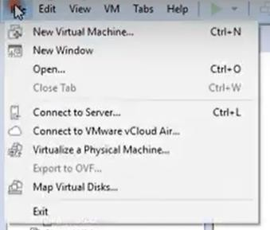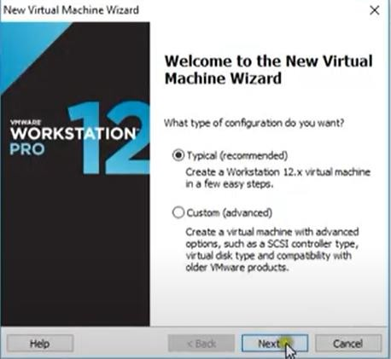

* Select I will install the OS later -> Select Linux. Select the Red Hat Enterprise Linux 7 64-bit version from the dropdown

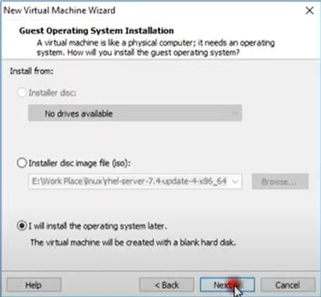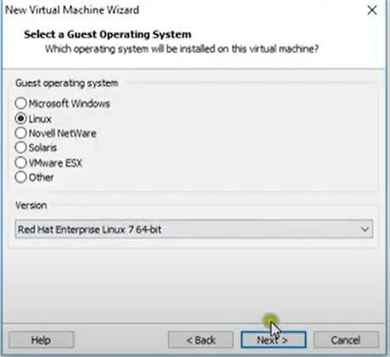

* Type the name and browse where you want to locate your virtual machine -> Put Maximum disk space to 40 GB.

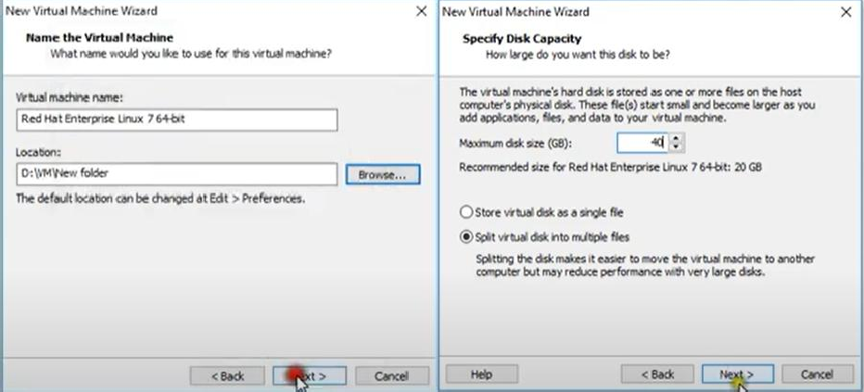

* Select Customize Hardware -> Select memory to 4GB .

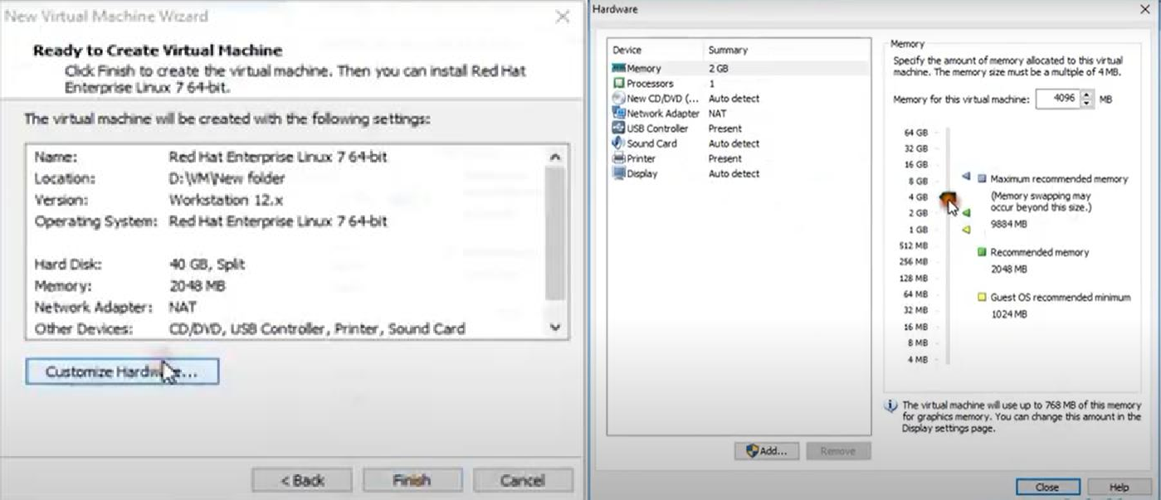

* Insert and browse your .iso file in CD/DVD. Then power on the virtual machine.

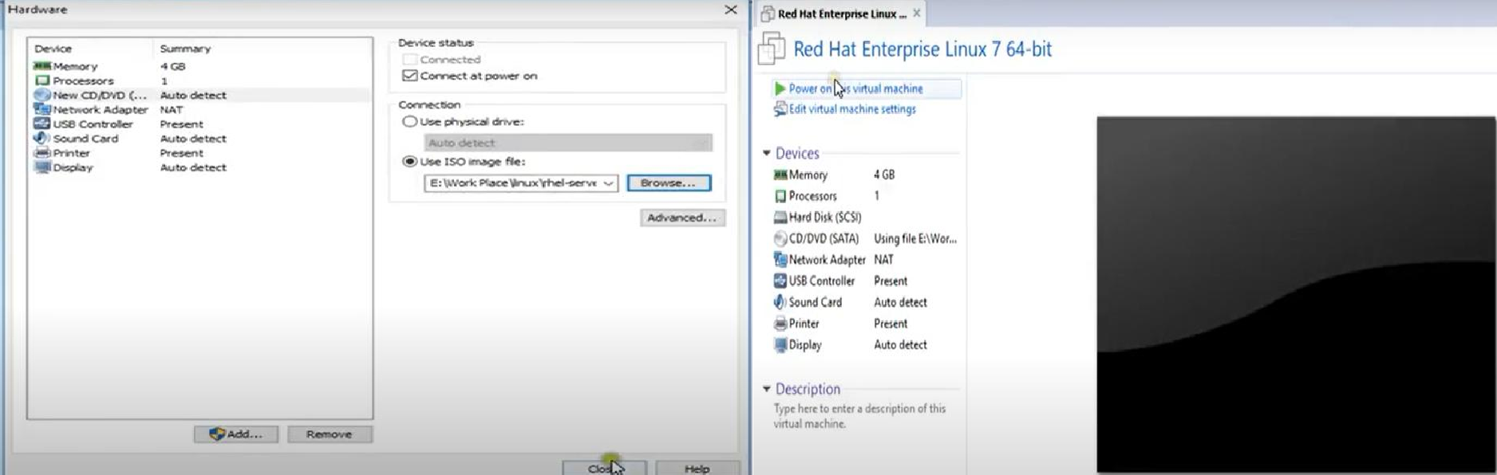

* Select install Red Hat Enterprise Linux 7.4

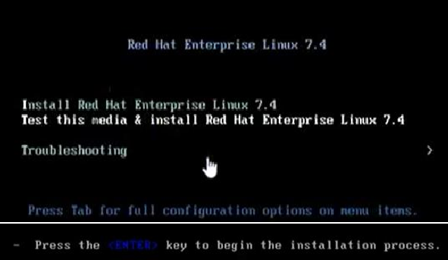

* Select the language and go to Software Selection

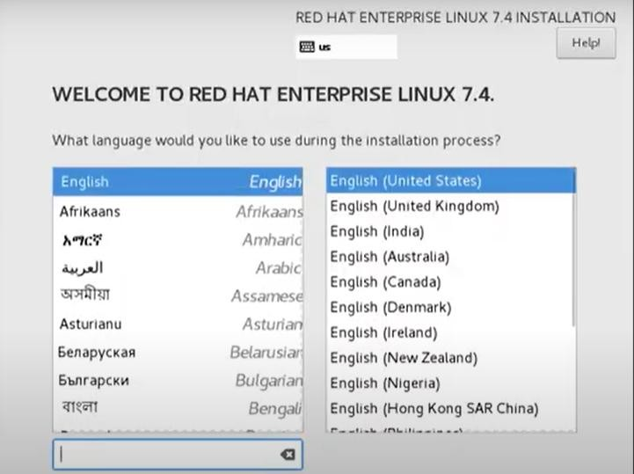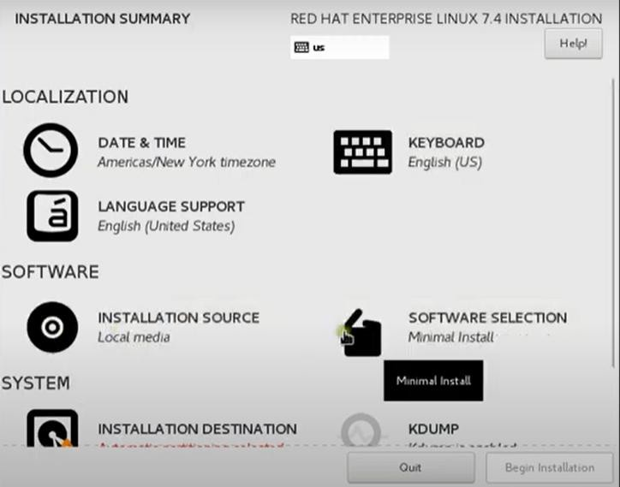

* Select Server with GUI and check Virtualization Client & Virtualization Hypervisor. And then began Installation.

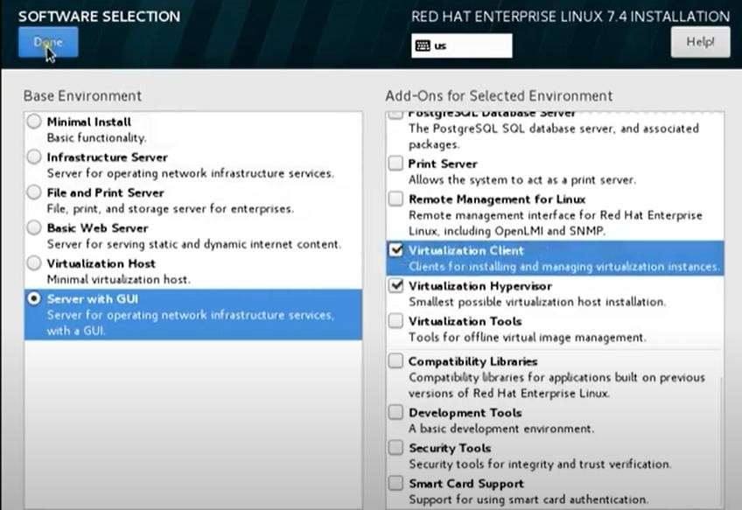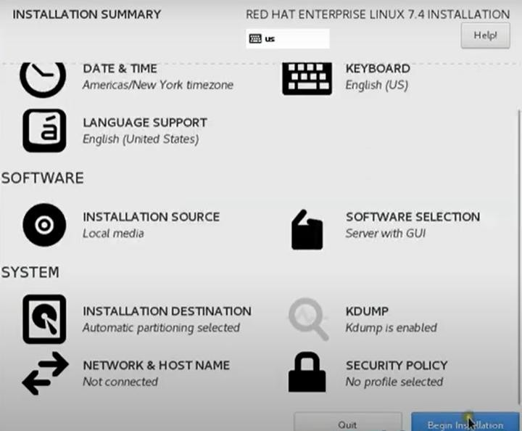

* Select Root Password. Type the root password.

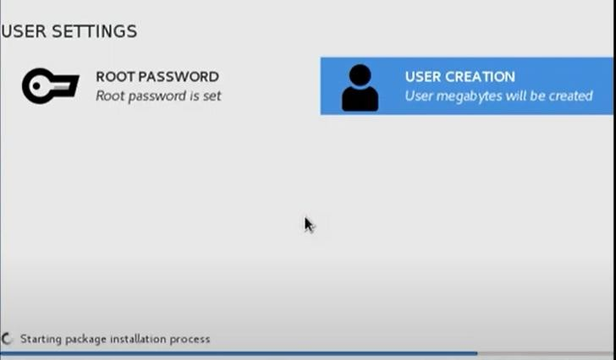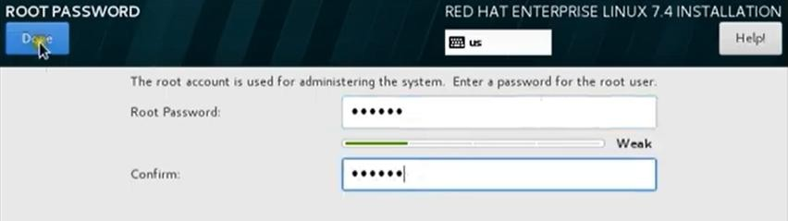

* Go to user creation and then enter the details. Click on Reboot.

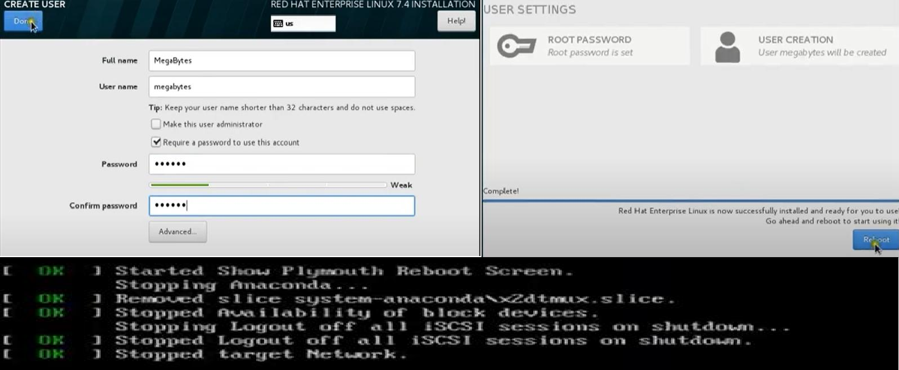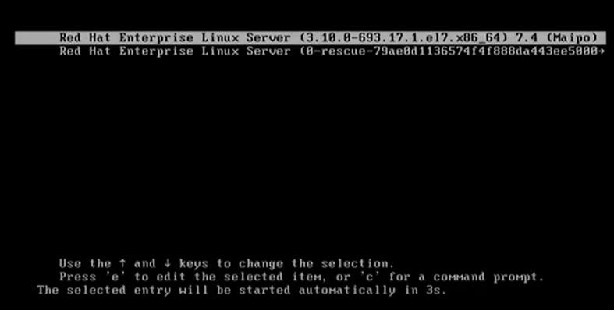

* Select Linux Information and accept the conditions.

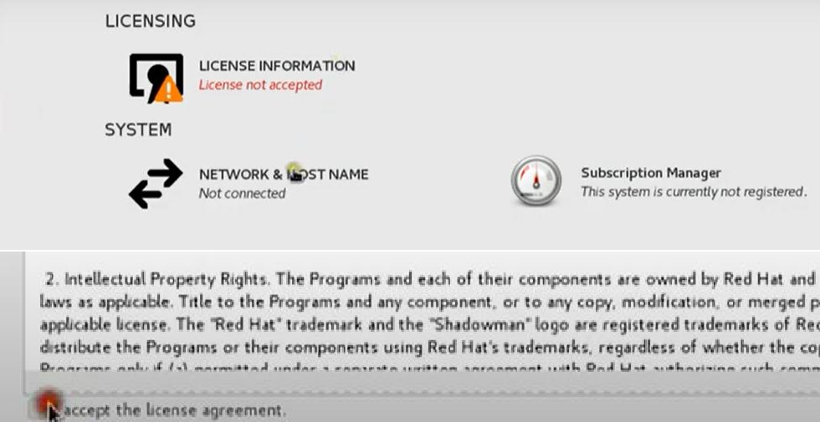

* Your account will appear -> type the password.

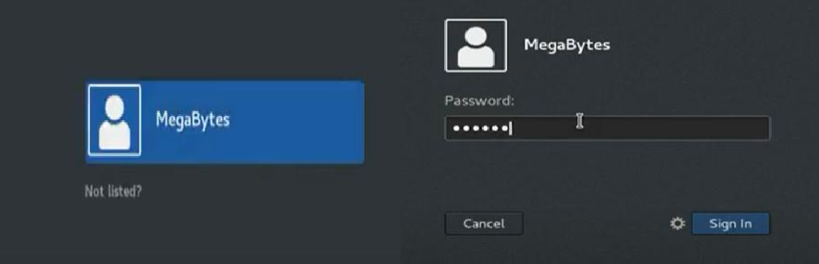

* Your Desktop will appear.

